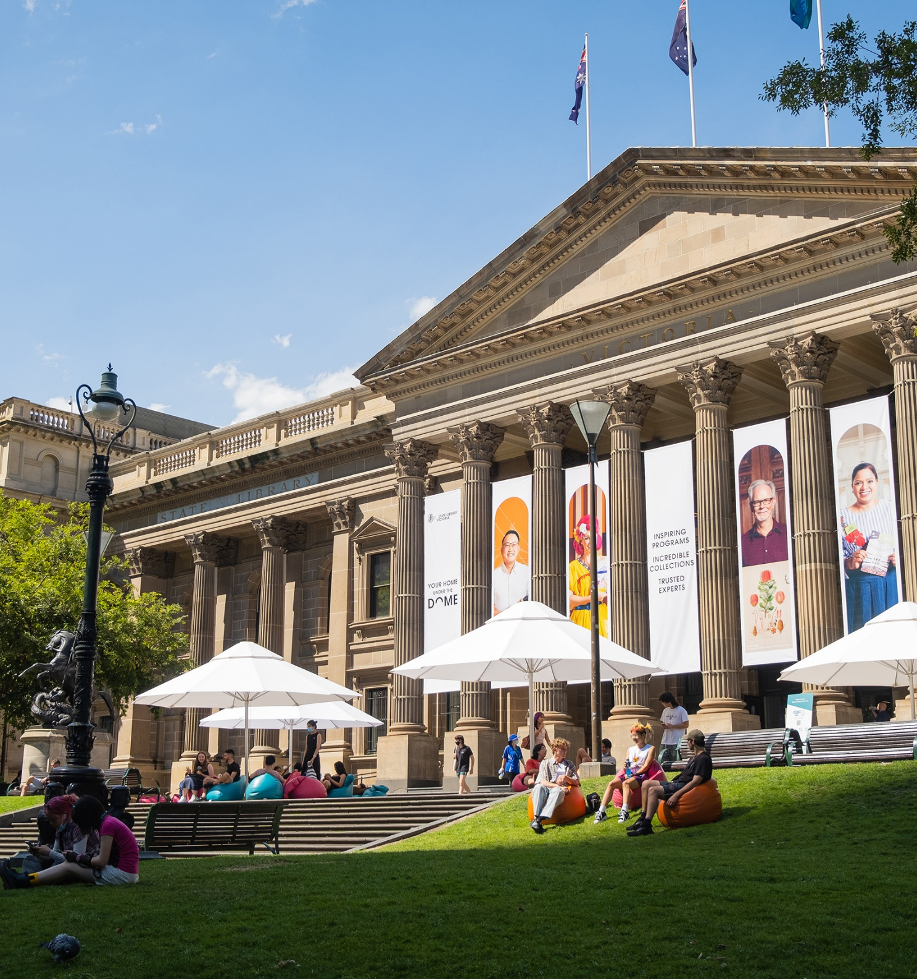
2025/2026

Disability Access & Inclusion Plan


Disability Access & Inclusion Plan
Contents
Contents 2
Acknowledgement of Country and People 2
How to give feedback about this plan 3
Language in this plan 3
Message from the CEO 4
A passion for books and culture 5
How we work 7
Strengthening our strategy 8
Disability Access & Inclusion Plan 2025/2026 10

Acknowledgement of Country and People
State Library Victoria acknowledges the traditional lands of all the Victorian Aboriginal clans, and their cultural practices and knowledge systems. We recognise that our collections hold traditional cultural knowledge belonging to Indigenous communities in Victoria and around the country. We support communities to protect the integrity of this information, gathered from their Ancestors in the colonial period. We pay our respects to their Elders, past and present, who have handed down these systems of practice to each new generation for millennia.

How to give feedback about this plan
You can tell us what you think about this plan.
You can:
- Contact us online via our feedback form
- Call us on 03 8664 7000
- Contact the National Relay Service if you need help to speak or listen
- Write to us at State Library Victoria, 328 Swanston Street, Melbourne 3000
State Library Victoria staff can contact the Inclusion Partner about the plan.

Language in this plan
Whatever words you use to talk about yourself and your experiences, this plan is for you.
Language in the disability community is always evolving. In this plan, we most often use ‘Deaf and disabled people’, which is most common in the cultural sector. This language reflects the social model of disability and the unique culture, language and identity of the Deaf community.
Many people in Australia prefer ‘person-first’ language, such as ‘people with disability’. We respect and affirm this language also. We use ‘people with disability’ in this plan when referencing research or legislation that uses this language.
We also acknowledge the diversity of people who experience barriers in the community and the workforce due to the interaction of their physical, sensory, intellectual, psychological, learning and neurological characteristics with inaccessible physical and social environments. Not everyone who experiences these barriers identifies with ‘disability’.
The experience of individuals with disability can be nuanced depending on gender, cultural background, sexuality, health, financial circumstances and where they live.
Disability can be permanent or temporary. Examples of permanent disability include dyslexia or cerebral palsy. Examples of temporary disability include musculoskeletal injuries or symptoms associated with perimenopause. Both permanent and temporary disability may affect how a person can be part of their community and their workplace, and may require adjustments to support the person’s participation.
We use ‘Deaf and disabled people’ in this plan to include everyone in this broad spectrum of experiences and preferences.

Message from the CEO
I’m proud to present the State Library Victoria’s Disability Access & Inclusion Plan for 2025 and 2026.
This plan details the Library’s commitments to improving the experiences of Deaf and Disabled employees, visitors and audiences, and by extension the experience of their families, friends and carers who often come with them to the Library.
We want Deaf and Disabled people to immerse themselves in everything State Library Victoria has to offer, without barriers. And we want the Victorian community to benefit from the creativity, leadership, skills and voices of Deaf and Disabled people.
This Disability Access & Inclusion Plan is for 2025 and 2026. This realigns the plan with our Strategic Plan 2022–26 and with the Inclusive Victoria: state disability plan (2022–2026). And with the Victorian Government planning a new Disability Inclusion Act, this timeframe also allows us to incorporate any new legislative requirements into our next Disability Access & Inclusion Plan.
The vision of our Strategic Plan is to be a library for all in a changing world. To meet the ambitious goals of our Strategic Plan, we must be accessible, relevant and inspiring for the 17% of Victorians who are Deaf or Disabled.
We also recognise our obligation and the opportunity to contribute to the outcomes of the state disability plan. We are one of Melbourne’s most-visited tourist destinations, and a home for learning and debate. The actions we take reach millions of Victorians and visitors each year, contributing to more inclusive communities and shifting attitudes towards Deaf and Disabled people.
I thank the Library’s disability and access staff network for their input to this plan, and acknowledge the support of the Australian Disability Network on our journey towards a more accessible, inclusive and equitable Library for Deaf and Disabled people.
Paul Duldig, CEO

A passion for books and culture
More than 1.1 million Victorians have disability, and libraries and literature are important to them.
Approximately 26% of Victorians with disability visited a public library in 2018. People with disability are more likely to read for pleasure than other Australians, to attend writers’ talks and book launches, and are more likely to make art, including creative writing.
Over 50% of people aged 65 or over have disability. This age group are also among the strongest who read for pleasure.
Despite higher rates of unemployment and a lower average household income, people with disability are more likely to give time or money to arts and culture.
Deaf and Disabled people care about culture, but they often face barriers to being part of it. In 2022, people with disability were less likely to attend live cultural events than people without disability, although people with intellectual disability were more likely to attend live cultural events than Australians overall.

Acting on the evidence
The actions in this plan draw on the Mapping Inclusive Services project, a major strategic project that mapped the experiences of specific user groups when visiting the Library and accessing our services. These user groups were:
- people who are blind or have low vision
- neurodivergent people with sensory needs
- people who are Deaf and hard of hearing
- people with complex needs (alcohol and other drugs or facing housing insecurity).
A key action in the plan is to prioritise the recommendations of the Dignified Access Review, completed as part of the Library’s membership with the Australian Disability Network in 2024. The review assessed the accessibility of Library workspaces for employees.
Both the Mapping Inclusive Services project and the Dignified Access Review captured the voices and experiences of Deaf and Disabled people.
Several actions from the Library’s previous Disability Access & Inclusion Plan 2022-24 have also been carried over into this plan.

Filling gaps in our data
The Library collects data about Deaf and Disabled visitors, audiences and staff in many ways (in accordance with the Victorian Information Privacy Principles). We know that this data tells an incomplete story, either because of the way it’s collected, or because people may not want to share their personal information with us.
One of the projects in this plan is to look closely at our sources of data, to better understand:
- the quality of this data
- where the gaps are in our data
- how we can improve the way we collect information about Deaf and Disabled people.
This will help us create an even stronger evidence-base for our next plan, alongside listening to and collaborating with Deaf and Disabled people.

How we work
Everything in this plan is based on two important principles: the social model of disability and ‘nothing about us without us’. We also must meet the 4 goals of the Disability Act 2006 (Vic).

Social model of disability
The social model of disability focuses on environmental and social barriers to inclusion, rather than seeing disability as deficits experienced by individuals. We focus on removing barriers to equal participation.
This aligns with Victoria’s Charter of Human Rights and Responsibilities Act 2006 and State Disability Plan, and the UN Convention on the Rights of Persons with Disability.
Deaf and Disabled people may experience barriers in relation to a range of different physical, sensory, psychiatric, neurological, intellectual and learning related conditions or attributes.

‘Nothing about us without us’
We know that when Deaf and Disabled people are involved in design, we get better results.
Over the life of this plan, we will continue to improve how we collaborate with Deaf and Disabled creatives, visitors and staff. We aspire to move beyond consultation to embed co-design as part of how we work.
This approach already has solid foundations in our programming, exhibitions and digital experiences. We will continue to support these ways of working, and build on this across all areas of work.

Legislative aims
The Victorian Disability Act 2006 requires all public sector bodies to develop action plans that:
- reduce barriers to people with disability accessing information, services and facilities
- reduce barriers to people with disability in obtaining and maintaining employment
- promote inclusion and participation in the community of people with disability
- achieve tangible changes to attitudes and practices which discriminate against people with disability.

Strengthening our strategy
Because Deaf and Disabled people are a core segment of Victoria’s cultural workforce and audience, our Disability Access & Inclusion Plan is essential to delivering on the 5 goals of the Library’s Strategy 2022-26.

Become a must-do destination
The Library precinct is a vibrant hub of activity, showcasing the collection, profiling expertise and maximising the use of our world-class spaces. We have inspired new audiences, visitors, scholars and tourists to engage with the Library through our celebrated curated programs and deep expertise.
People with disability attend literary events at a higher rate than other Australians, but are less likely to attend live cultural events in general. The main barriers people report are getting to events, concerns about safety at events, and the cost of attending.
To meet our visitation and visitor satisfaction goals, our spaces and programs must be accessible, inviting and inspiring for Deaf and Disabled people and their friends, families and carers.

Create a compelling digital experience
The Library’s rich collection is accessible to all through a compelling digital experience, inspiring visitors to respond in creative and thoughtful ways.
People with disability are more likely than those without to use the internet to create art or learn to create art, and to use other digital platforms to engage with art. They are also more likely than other Australians to attend all types of arts events online, including book clubs and literary events. Deaf and Disabled people are often enthusiastic and creative adopters of new technologies, which can enhance their lives and help to overcome barriers.
To meet our digital engagement and satisfaction targets, Deaf and Disabled creators, history-lovers and literary enthusiasts must be valued co-creators of our digital experiences and opportunities.

Strengthen diverse communities
Victoria’s diverse communities are strengthened through their connection with the Library, seeing genuine relevance and representation in our collecting, and valuing their engagement with our collection, exhibitions, programs and staff.
About 17% of Victorians have a disability. They may be part of a disability community and have a strong sense of disability pride. They may more strongly identify with the community of their family, culture, neighbourhood or town, or be immersed in communities based on their interests or social and professional networks. Deaf and Disabled people have their own unique communities and are part of every other Victorian community.
Our collections, exhibitions and programs must reflect this diversity of experience, participation and creative production.

Become an active community voice for learning, knowledge and culture
We are a leader in learning, knowledge and culture. The Victorian community actively engages with the Library as a trusted place to explore current issues, provoking questions, learning and debate.
People with disability are active users of public libraries. In 2018, 26% of people with disability visited a public library, compared with 20% of people without disability.
And because 17% of the Victorian population has disability, State Library Victoria must harness the creativity and thought leadership of Deaf and Disabled artists, innovators and scholars to truly reflect the depth and breadth of current issues and questions.

Deliver innovative and sustainable operations
We are innovative and sustainable in delivering the programs and services that our community needs. Our skilled and diverse staff have the right tools and infrastructure, and we have secured a sustainable funding base, augmented by additional revenue maximising community impact.
To access the broadest talent pool and recruit and retain the best professionals, we must strive for accessible and inclusive recruitment, workspaces and ways of working.

Disability Access & Inclusion Plan 2025/2026

Outcome 1
The Library can make evidence-based decisions that benefit Deaf and Disabled people.

Sponsor
Chief Operating Officer

Actions for this plan
- Collate and report on data sources related to Deaf and Disabled visitors, service users and program attendees, including considering data limitations and recommendations to improve data quality.

Outcome 2
Digital experiences are relevant, inspiring and accessible for Deaf and Disabled audiences.

Sponsor
Chief Digital Officer

Actions for this plan
- Build accessibility into website redesign, including WCAG2.2 standards and other best practices, and working with Deaf and Disabled people throughout development
- With Deaf and Disabled people, conduct accessibility testing and evaluation of key public-facing digital products
- Explore opportunities to invite Deaf and Disabled digital creatives and technologists
- Include accessibility as a core principle in all digital and technology strategies
- Written communications across digital platforms are in simple English, with Easy English translations considered for relevant communications
- Create opportunities for Library staff to upskill in digital accessibility

Outcome 3
All visitors can independently and confidently plan a visit to the Library.

Sponsor
Director Experience

Actions for this plan
- Investigate and systematically apply uniform accessibility icons across What’s On and other Library-owned channels, and front-of-house signage
- Develop guides, interactive maps, social scripts and other aids which describe or depict the experience of being in the Library, including for special events
- Provide relevant, accessible access information on the Library’s website by continuously updating the Access and Inclusion webpages
- Update wheelchair booking system to enable a smoother process for visitors requiring a wheelchair

Actions for future
- Publish and maintain guides, interactive maps, social scripts and other aids developed during this plan

Outcome 4
All visitors can independently and confidently navigate the Library.

Sponsor
Director Experience

Actions for this plan
- Investigate how to improve explicit and implicit communication about how our different spaces can be used, such as developing naming principles for Library spaces
- Make accessibility considerations fundamental to the design of any outcomes of the Wayfinding Project and 3D Wayfinding Project

Actions for future
- Investigate opportunities to make staff more clearly identifiable

Outcome 5
Deaf and Disabled visitors feel welcome at the Library.

Sponsor
Director Experience

Actions for this plan
- Explore ways to incorporate welcoming and inclusive messaging across Library spaces, including entries
- Work with relevant community organisations to deliver targeted invitations and marketing for events and programs
- Continue to work with relevant community organisations to develop meaningful engagement opportunities for identified groups (such as Auslan or audio-described exhibition tours or tours design with/for neurodiverse audiences), and embed this way of working in the programming charter
- Become a distribution point for Hidden Disabilities Sunflower merchandise
- Investigate training options and develop a training plan for visitor-facing staff, event staff and Learning Program Facilitators to improve their ability to respond to the needs of Deaf and Disabled visitors

Outcome 6
Visitors have access to low-sensory environments or sessions.

Sponsor
Director Experience

Actions for this plan
- Seek expert advice to develop guidelines for consistent implementation of low-sensory, trauma-informed spaces and supports for select events and sessions
- Develop a plan to communicate with relevant audiences about the availability of low-sensory spaces
- Review sensory experience of existing designated quiet spaces
- Trial low-sensory hours in public spaces

Actions for future
- Improve sensory experience of existing designated quiet spaces, based on review undertaken during this plan

Outcome 7
Visitors are empowered and supported to use our services and collections.

Sponsor
Head of Visitor and Information Services

Actions for this plan
- Trial visual representations of Library processes at service points
- Investigate and implement solutions to make collection accessible to braille users, including potential for braille machine at Assistive Technology station, and catalogue functionality
- Ensure multiple communication options (phone, email, online forms) are available when requesting collection items
- Review Heritage Collection Reading Room operations to ensure ordering and visiting are accessible for all
- Trial a Digital Adoption Platform (built-in automated tour guide) for the Library catalogue
- Upgrade the Library’s Discovery System to conform to accessibility standards, offer a user interface in multiple languages and a voice assistant
- Provide a low-sensory private assistive technology option in a bookable studio
- Continue to conduct user-centred research about access to catalogues and online services

Outcome 8
Programming and exhibitions are relevant, inspiring and accessible for audiences with disability.

Sponsor
Director Experience

Actions for this plan
- Continue to embed, review and improve accessible exhibition practices, with accessibility checkpoints and best practice approaches to be integrated into the exhibition development guide
- Develop best-practice guidelines and an accompanying implementation plan for programming, fellowships, exhibition design and communications as part of the program charter
- Offer Companion Card tickets to all events, and other individual ticket types for accessibility
- Post-event surveys are accessible and use simple English

Outcome 9
Creatives, scholars and other contracted professionals are empowered to contribute their best work to Library programs and other activities.

Sponsor
Chief Operating Officer

Actions for this plan
- Assess and improve how demographic data about creatives, scholars and other professionals engaged for programs and exhibitions is collected
- Explore best practice ways to incorporate accessibility requirements into Library agreements

Actions for future
- In the next plan, embed a relevant Library-wide target for engaging Deaf and Disabled creatives, scholars and other professionals in programs and exhibitions

Outcome 10
All new technology and platforms are accessible to all users.

Sponsor
Chief Digital Officer

Actions for this plan
- Embed accessibility as a core criteria for procurement of all new technology and digital platforms for users and staff
- Seek feedback from users of assistive technology to ensure it meets their needs
- Maintain a maintenance schedule for assistive technology

Outcome 11
Collections are relevant, inspiring and accessible for Deaf and Disabled people

Sponsor
Director Collections

Actions for this plan
- Continue to improve representation of deaf and disabled people in the collection through acquisition
- Continue digitisation of the Library’s collection to improve access

Outcome 12
Physical workspaces are accessible and dignified for all staff.

Sponsor
Chief Operations Officer

Actions for this plan
- Develop a prioritisation plan for the recommendations of the Dignified Access Review and begin implementation of priority actions

Outcome 13
Library staff are empowered to do their best work.

Sponsor
Director People & Partnerships

Actions for this plan
- Work with the Australian Disability Network to review and improve workplace adjustment policy and process
- Train all managers about workplace adjustments and the Library’s policy and processes

Outcome 14
The Library is ready to contribute to the Victorian Public Sector 12% disability employment target.

Sponsor
Director People & Partnerships

Actions for this plan
- Investigate quality of data sources related to disability employment, and develop recommendations to improve this

Actions for future
- Seek expert advice to review and improve accessibility of recruitment processes
- Explore targeted methods to recruit Deaf and Disabled people, including working with Disability Employment Services or using special measures under the Equality Opportunity Act.

Australian Bureau of Statistics, Survey of Disability, Ageing and Carers, 2018 and 2022.
Australian Bureau of Statistics, Attendance and Selected Cultural Venues and Events, Australia, 2019. This is the most recent data available about public library visitation by people with disability.
Australia Council for the Arts, Creating our Future: Results of the National Arts Participation Survey, 2020.
Creative Australia, Creating Value: Results of the National Arts Participation Survey, 2023.
Creative Australia, Creating Value: Results of the National Arts Participation Survey, 2023.
Australian Bureau of Statistics, Survey of Disability, Ageing and Carers, 2022.
Australia Council for the Arts, Creating Value: Results of the National Arts Participation Survey, 2023.
Australian Bureau of Statistics, Survey of Disability, Ageing and Carers, 2022.
Creative Australia, Creating Value: Results of the National Arts Participation Survey, 2023.
Creative Australia, Creating Value: Results of the National Arts Participation Survey, 2023.
Australia Council for the Arts, Creating Value: Results of the National Arts Participation Survey, 2023.
Australia Council for the Arts, Creating Value: Results of the National Arts Participation Survey, 2023.

